Canon Davis Memorial Church
380 Russell St. North, Sarnia, Ontario, N7T 6S6
(519) 344-9531 - http://www.canondavis.com
Third Sunday of Advent, December 13th, 2020
ISAIAH 61:1-4, 8-11● Psalm 126 or Canticle 18 (Luke 1:47-55);
1 Thessalonians 5:16-24● John 1:6-8, 19-28

Dear Friends,
This is one unusual year. So much of what we normally would be doing is not taking place. At the same time, much is taking place that we never thought we would see. Emotions tend to be running in high gear.

We are in Advent; the time of year when we prepare for the celebration of the coming of the baby Jesus into our often troubled world. Advent is a time for reflection and for preparation. But this year there is a difference. Christmas trees have already been sold out. There is no Christmas parade in the usual sense. Lighting displays are becoming more numerous. Instead of a parade taking place, many parades are taking place — parades of cars going by lighting displays throughout the region.

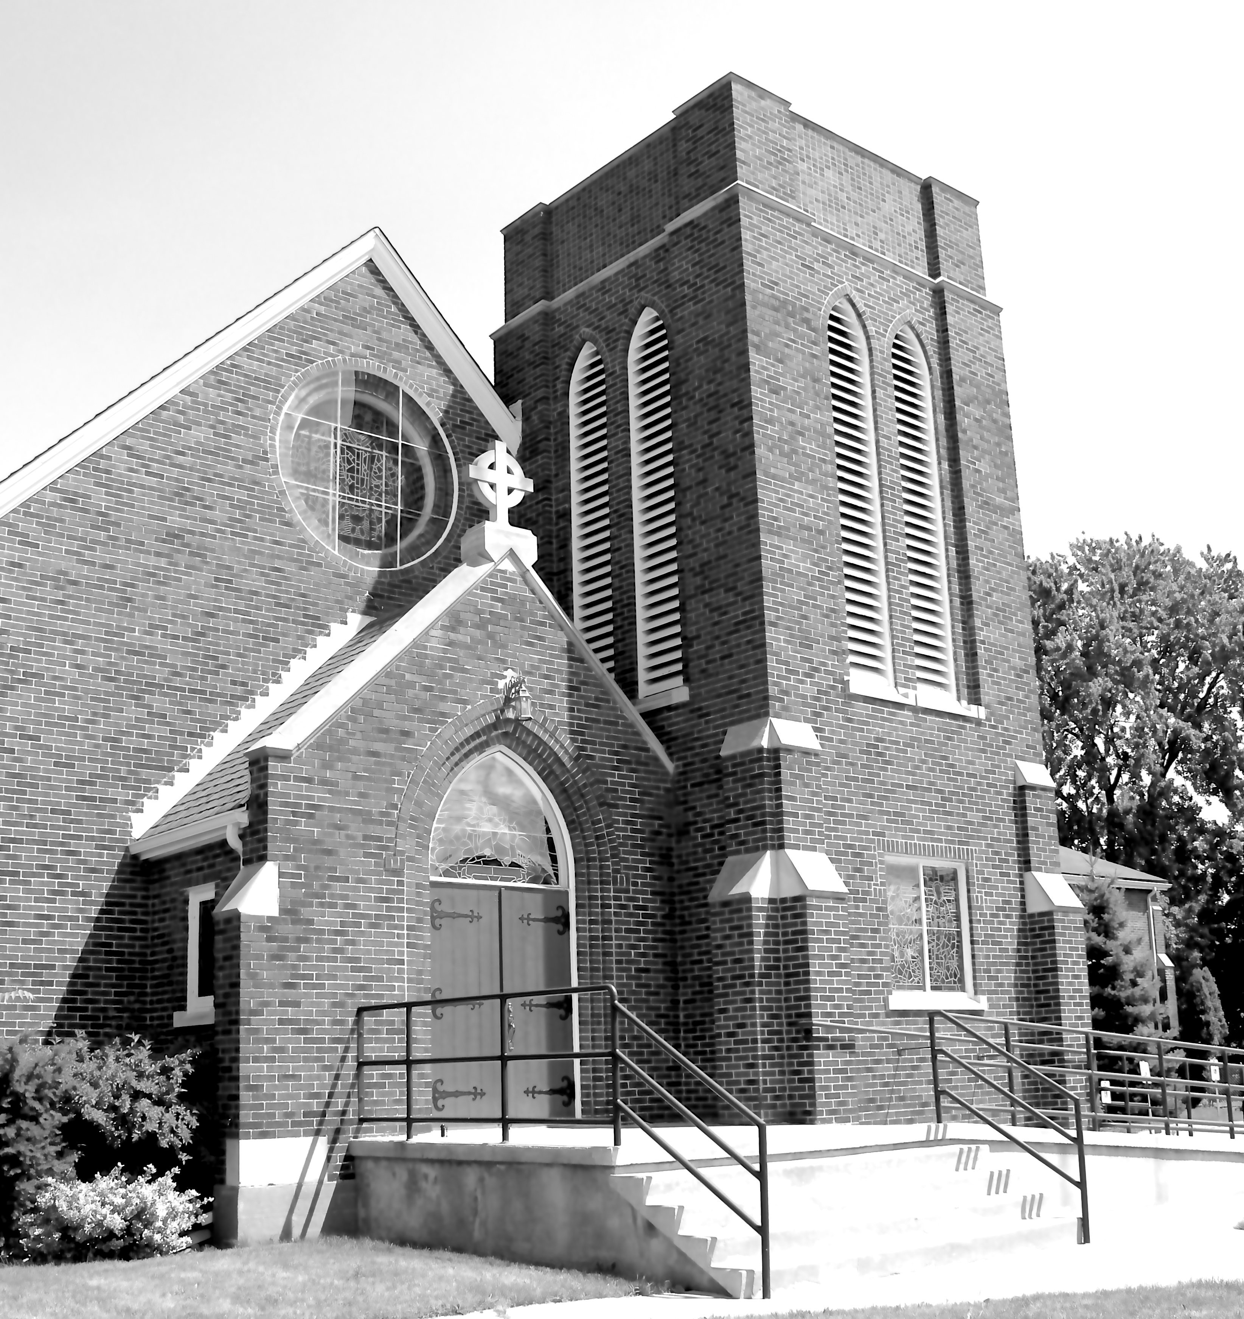
My Grandmother always had a remedy for dealing with the unexpected obstacles that happen in life. “Make do”, she would say to us. And Sarnians have been very good at “making do” this year.

But, and it seems there is a “but” following many optimistic sentences. But, we all can feel it. Things are not the same. We still look forward to things being the way they once were. And while this may not fully happen; we sense that getting back to many of our traditions is indeed important, is life giving.

There are many joys to experience in these traditions. Two are particularly important. One is in experiencing the tradition itself; the other is in preparing for the tradition. When we prepare for a joyous occasion, we ultimately find that we are focusing our attention on the experience of the people who will take part in the event. We wonder if the meaning of the celebration will be felt in the hearts of those who come to participate. Will it stimulate further actions in support of the theme of the celebration? Will it re-enforce the true meaning of the event and help bring about new supportive ways of seeing the world and its people?

A Christmas tree; Christmas boughs; other greens; ribbons; Manger scenes; Christmas music; and visits from other people; all of these and more add to the occasion of Christmas. The neat thing is that the meaning of Christmas can take place with all or none of these outward expressions. It all depends on what Christmas means to us, individually. Whether we want to make a full outward display or if we desire a quiet time for inward reflection on what the birth of the Christ child means deep within us; we find value in making adequate preparation.

Without preparation, there is seldom the same level of celebratory impact. Part of our preparation is found in setting the right mindset toward what we want to achieve. That is something that John the Baptist knew so very well. He was called to prepare the way of the Lord into peoples’ lives. He knew that many people wanted a new start in life and would be receptive for the act of baptism. John was able to make a strong mark for people to be open to the work of Jesus when he entered their lives. John prepared the way really well.

We too are to be prepared for faith building moments as we prepare for the celebration of the birth of Emmanuel, God with us. It it is well for us to reflect on the presence of Christ in our hearts. For Christ dwells in our hearts as an expression of how much he loves us. The love of Jesus is a love that is eternal and unconditional. May we ever be aware of that love, manifested in our lives. In all circumstances may we be prepared to share that love.

God’s blessing be upon you and all those you love.

——————————————————————————-
——————————————————————————-

Christmas Memorial Fund

Because of COVID-19, there will not be a beautiful display of Poinsettias in the church for Christmas. Therefore, there will not be a Poinsettia Fund this year to give towards in memory of our loved ones, and a printed list issued. Instead, we will have a Christmas Memorial Fund to give towards in memory of our loved ones. A printed list will be issued the same as the Poinsettia Fund list. Please note on your envelope Christmas Memorial and the amount. If you have any changes to your memorial note that will be printed please contact Karen in the office. Thank you.

——————————————————————————-

You are invited to go each Sunday and/or Wednesday to the link:
tinyurl.com/StAlbans-CDMC

That is the link to St. Alban’s Anglican Church in Burnaby B.C. Follow the instructions. You will find links to the Rev’d Greg Jenkins officiating at an Anglican church service with children’s focus, church music, readings, prayers and a sermon.
If you are also interested in joining their weekly Bible Study, contact Rev. Greg at revgregjenkins@gmail.com He will be more than happy to be in touch about joining in with their group by ZOOM. I hope you will find these services help to deepen your faith.
——————————————————————————-

We are joining with many parishes in our deanery in providing telephone support to our members and friends. This support is designed to keep us up to date, while not requiring a computer. The CDMC Pastoral Letter will be read this week through our phone ministry.

