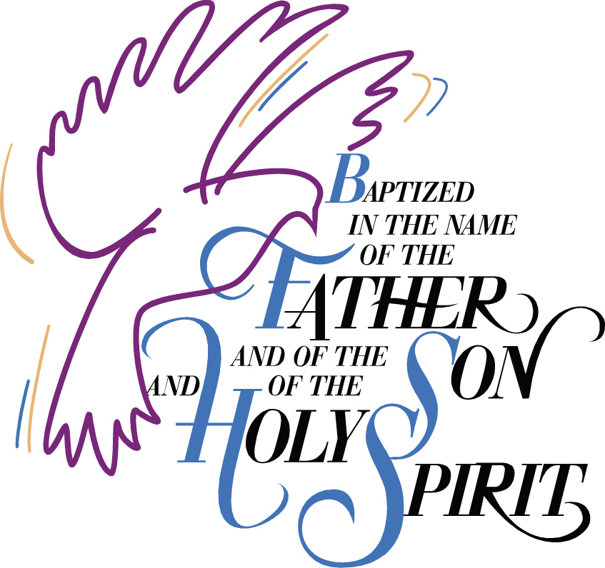
Baptism
of
Matilda Winnie D’Ippolito
15 August 2021
Born 2April 2021
Sarnia, Ontario
Canada

Canon Davis Memorial Church
Anglican Church of Canada
Sunday August 15, 2021 -- Twelfth Sunday after Pentecost
9:30 a.m. Holy Baptism and Holy Eucharist
Officiant—Rev’d Paul Woolley — Organist—Dorothy Miller

THE GATHERING OF THE COMMUNITY
Opening Hymn #415 All Things Bright and Beautiful
The grace of our Lord Jesus Christ, and the love of God, and the fellowship of the Holy Spirit, be with you all.
And also with you.
There is one body and one Spirit,
There is one hope in God’s call to us;
One Lord, one faith, one baptism,
One God and Father of all.
The Lord be with you.
And also with you.
COLLECT: O God, you have taken to yourself the blessed Virgin Mary, mother of your incarnate Son. May we who have been redeemed by his blood, share with her the glory of your eternal kingdom; through Jesus Christ our Lord, who lives and reigns with you and the Holy Spirit, one God, now and for ever. Amen.

PROCLAMATION OF THE WORD
1st Reading: Isaiah 7: 10-15
Psalm: 132: 6-10, 13, 14
2nd Reading: Galatians 4: 4-7
Gospel: Luke 1: 46-55

THE HOLY GOSPEL OF OUR LORD JESUS CHRIST
ACCORDING TO LUKE

Glory to you, Lord Jesus Christ
Mary said, "My soul magnifies the Lord, and my spirit rejoices in God my Saviour, for he has looked with favour on the lowliness of his servant. Surely, from now on all generations will call me blessed; for the Mighty One has done great things for me, and holy is his name. His mercy is for those who fear him from generation to generation. He has shown strength with his arm; he has scattered the proud in the thoughts of their hearts. He has brought down the powerful from their thrones, and lifted up the lowly; he has filled the hungry with good things, and sent the rich away empty. He has helped his servant Israel, in remembrance of his mercy, according to the promise he made to our ancestors, to Abraham and to his descendants forever."
The Gospel of Christ
Praise to you Lord Jesus Christ
Sermon
Sermon Hymn #312 Sing a New Song unto the Lord

The Presentation
I present Matilda Winnie to receive the sacrament of baptism.
Will you be responsible for seeing that the child you present is nurtured in the faith and life of the Christian community?
I will, with God’s help.
Will you by your prayers and witness help this child to grow into the full stature of Christ?
I will, with God’s help.
Do you renounce Satan and all the spiritual forces of wickedness that rebel against God?
I renounce them.
Do you renounce the evil powers of this world which corrupt and destroy the creatures of God?
I renounce them.
Do you renounce all sinful desires that draw you from the love of God?
I renounce them.
Do you turn to Jesus Christ and accept him as your Saviour?
I do.

Do you put your whole trust in his grace and love?
I do.
Do you promise to obey him as your Lord?
I do.
The Congregation is addressed:
Will you who witness these vows do all in your power to support these persons in their life in Christ?
We will.
Prayers
Let us now pray for these persons who are to receive the sacrament of new birth.
Deliver them, O Lord, from the way of sin and death.
Lord, hear our prayer.

Open their hearts to your grace and truth.
Lord, hear our prayer.

Fill them with your holy and life-giving Spirit.
Lord, hear our prayer.

Teach them to love others in the power of the Spirit.
Lord, hear our prayer.

Send them into the world in witness to your love.
Lord, hear our prayer.
Bring them to the fullness of your peace and glory.
Lord, hear our prayer.

Grant, O Lord, that all who are baptized into the death of Jesus Christ your Son may live in the power of his resurrection and look for him to come again in glory; who lives and reigns now and for ever. Amen.
The Lord be with you.
And also with you.

Let us give thanks to the Lord our God.
It is right to give our thanks and praise.

We thank you, Almighty God, for the gift of water. Over water the Holy Spirit moved in the beginning of creation. Through water you led the children of Israel out of their bondage in Egypt into the land of promise. In water your Son Jesus received the baptism of John and was anointed by the Holy Spirit as the Messiah, the Christ, to lead us, through his death and resurrection, from the bondage of sin into everlasting life. We thank you, Father, for the water of baptism. In it we are buried with Christ in his death. By it we share in his resurrection. Through it we are reborn by the Holy Spirit. Therefore in joyful obedience to your Son, we bring into his fellowship those who come to him in faith, baptizing them in the name of the Father, and of the Son, and of the Holy Spirit. Now sanctify this water by the power of your Holy Spirit, that those who are here cleansed from sin and born again, may continue for ever in the risen life of Jesus Christ our Saviour. To him, to you, and to the Holy Spirit, be all honour and glory, now and for ever. Amen.

Let us join with those who are committing themselves to Christ and renew our own baptismal covenant.
Do you believe in God the Father?
I believe in God, The Father almighty, creator of heaven and earth.
Do you believe in Jesus Christ, the Son of God?
I believe in Jesus Christ, his only Son, our Lord. He was conceived by the power of the Holy Spirit and born of the Virgin Mary. He suffered under Pontius Pilate, was crucified, died, and was buried. He descended to the dead. On the third day he rose again. He ascended into heaven, and is seated at the right hand of the Father. He will come again to judge the living and the dead.
Do you believe in God the Holy Spirit?
I believe in God the Holy Spirit, the holy catholic Church, the communion of saints, the forgiveness of sins, the resurrection of the body, and the life everlasting.
Will you continue in the apostles’ teaching and fellowship, in the breaking of bread, and in the prayers?
I will, with God’s help.
Will you persevere in resisting evil and, whenever you fall into sin, repent and return to the Lord?
I will, with God’s help.
Will you proclaim by word and example the good news of God in Christ?
I will, with God’s help.
Will you seek and serve Christ in all persons, loving your neighbour as yourself?
I will, with God’s help.
Will you strive for justice and peace among all people, and respect the dignity of every human being?
I will, with God’s help.
Baptism
Matilda Winnie, I baptize you in the name of the Father, and of the Son, and of the Holy Spirit. Amen.
I sign you with the cross, and mark you as Christ’s own for ever.
Heavenly Father, we thank you that by water and the Holy Spirit you have bestowed upon these your servants the forgiveness of sin, and have raised them to the new life of grace.
Sustain them, O Lord, in your Holy Spirit. Give them an inquiring and discerning heart, the courage to will and to persevere, a spirit to know and to love you, and the gift of joy and wonder in all your works. Amen.
Receive the light of Christ, to show that you have passed from darkness to light.
Let your light so shine before others that they may see your good works and glorify your Father in heaven.
Let us welcome the newly baptized.
We receive you into the household of God. Confess the faith of Christ crucified, proclaim his resurrection, and share with us in his eternal priesthood.
The peace of the Lord be always with you.
And also with you.
Offering Hymn #431 Take Up Your Cross, the Saviour Said
Prayer over the Gifts
God of mercy, receive all we offer you this day. May we share with the Virgin Mary the joys of your eternal kingdom, and live with you in unending love. We ask this in the name of Jesus Christ our Lord. Amen
Eucharistic Prayer 2
The Lord be with you.
And also with you.
Lift up your hearts.
We lift them to the Lord.
Let us give thanks to the Lord our God.
It is right to give our thanks and praise.
We give you thanks and praise, almighty God, through your beloved Son, Jesus Christ, our Saviour and Redeemer. He is your living Word, through whom you have created all things. By the power of the Holy Spirit he took flesh of the Virgin Mary and shared our human nature. He lived and died as one of us, to reconcile us to you, the God and Father of all. In fulfilment of your will he stretched out his hands in suffering, to bring release to those who place their hope in you; and so he won for you a holy people. He chose to bear our griefs and sorrows, and to give up his life on the cross, that he might shatter the chains of evil and death, and banish the darkness of sin and despair. By his resurrection he brings us into the light of your presence. Now with all creation we raise our voices to proclaim the glory of your name.
Holy, holy, holy Lord, God of power and might, heaven and earth are full of your glory. Hosanna in the highest.
Blessed is he who comes in the name of the Lord. Hosanna in the highest.
Holy and gracious God, accept our praise, through your Son our Saviour Jesus Christ; who on the night he was handed over to suffering and death, took bread and gave you thanks, saying, “Take, and eat: this is my body which is broken for you.” In the same way he took the cup, saying, “This is my blood which is shed for you. When you do this, you do it in memory of me.” Remembering, therefore, his death and resurrection, we offer you this bread and this cup, giving thanks that you have made us worthy to stand in your presence and serve you. We ask you to send your Holy Spirit upon the offering of your holy Church. Gather into one all who share in these sacred mysteries, filling them with the Holy Spirit and confirming their faith in the truth, that together we may praise you and give you glory through your Servant, Jesus Christ. All glory and honour are yours, Father and Son, with the Holy Spirit in the holy Church, now and for ever. Amen.
Our Father, who art in heaven, hallowed be thy name, thy kingdom come, thy will be done, on earth as it is in heaven. Give us this day our daily bread. And forgive us our trespasses, as we forgive those who trespass against us. And lead us not into temptation, but deliver us from evil. For thine is the kingdom, the power, and the glory, for ever and ever. Amen.
We break this bread to share in the body of Christ.
We, being many, are one body, for we all share in the one bread.
Communion
The gifts of God for the People of God.
Thanks be to God.
Prayer after Communion
Ruler of the universe, all creation yearns for its fulfilment in your Son. May we who have shared in holy things grow into maturity in him. This we ask in the name of the same Jesus Christ our Lord. Amen

Glory to God, whose power, working in us, can do infinitely more than we can ask or imagine. Glory to God from generation to generation, in the Church and in Christ Jesus, for ever and ever. Amen.
Announcements
Hymn #505 Be Thou My Vision
Benediction Song Howard’s Blessing (vs1,2)
Today in lieu of memorial flowers from Joan and family,
we remember Garth Dew.

News and Events
- Please send all announcements for the bulletin to Karen by 11:00 a.m. Tuesday of each week. Call: 519-344-9531 or email: canondavis@gmail.com.
- To register your attendance at Sunday Services please contact the office at 519-344-9531. Thank you.

Reminders:

