Canon Davis Memorial Church

380 Russell St. North, Sarnia, Ontario, N7T 6S6
(519) 344-9531 • http://www.canondavis.com
DAY OF PENTECOST • May 23, 2021
Ezekiel 37:1-14 • Psalm 104:24-34, 35b
Romans 8:22-27 • Acts 2:1-21 • John 15:26-27; 16:4b-15

Dear Friends,
Summertime temperatures have just arrived with a bang. It seems to me like we just celebrated Christmas and Easter. These are two special days which celebrate the power of God entering into our lives. Now it is the time to celebrate a third day on the church calendar, the Day of Pentecost. It would be hard for us to not notice that we can learn much about our God and our faith as we focus on God’s actions in the holy events that took place so long ago and yet, take place in our hearts every year.

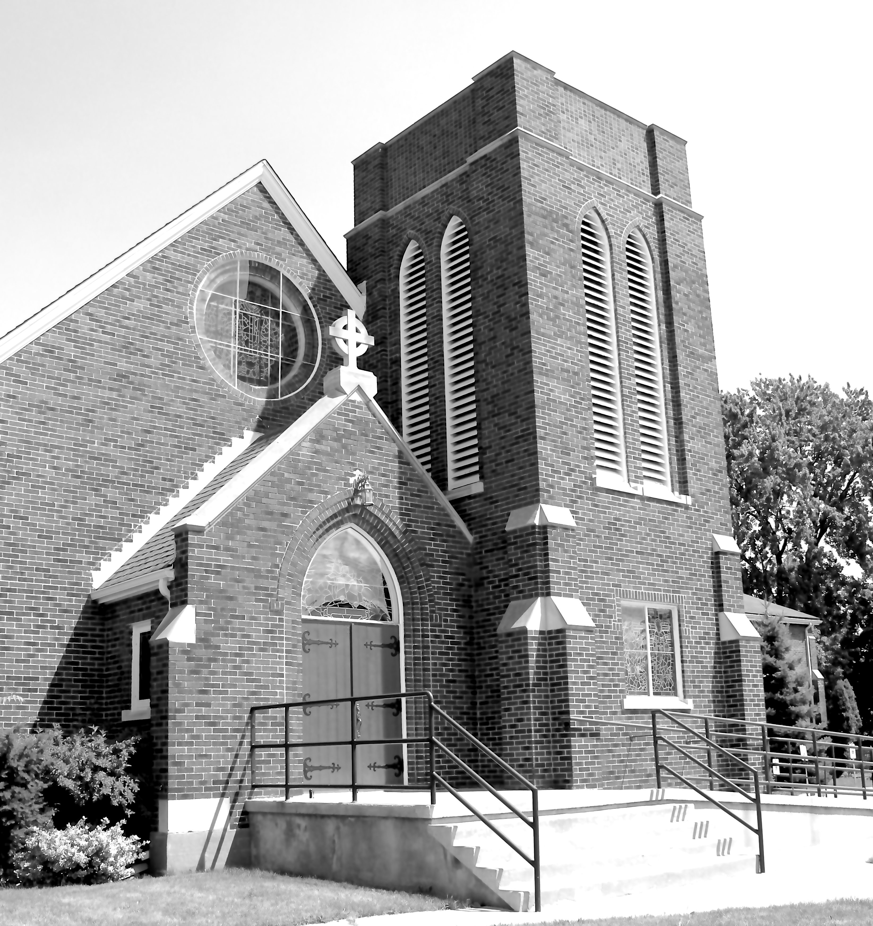
As the God of the universe, our Triune God does not conform to the nature of the gods created by people. God as we have come to know God, is full of life-giving surprises. Surprises like having his Son come into our world because of God’s infinite love for us. This he did by having him born in a stable (hardly a suitable place for the birth of God’s own). Also, consider how Jesus, as God’s Son, accepted dying on a cross in his love of us. This act was one of saving grace for all humanity. Without giving up his life, there could not be any resurrection!

Notice the pattern, here? What would we normally not expect from an Almighty God? ——> one that embraces that which is regarded by society as being weak. God has compassion for the weak. God also sees the power that can be found in weakness.

At the same time God does not hold back from doing mighty things, like making the earth and all that abides here. The stars in their constellations are God’s. Importantly, we all belong to God, as well. Yes, over 7 billion of us belong to God. It is amazing that the gift of the earth is able to support so many people — although with growing difficulty.

There are several references to interactions between the Holy Spirit and people in scripture. Some refer to the indwelling of the Holy Spirit within our hearts, as people. When one stands back a bit, one can see how the number of people experiencing this indwelling at any one time is huge.

As described in the book of Acts, the Pentecost event brings up strong images of the potential impacts the Holy Spirit can have. Here, we have the Spirit of God interacting with a large number of people. What is interesting and amazing is that this assortment of people included folk from many nations. They were all talking at once; and it must have sounded like gibberish! But through the working of the Holy Spirit, each person understood another. Contrast that with how difficult it is for us at times to understand each other in English!

So it is, regardless of how many of us there are, God comes closer to each of us than we may typically think. The God that we cannot see is infinitely huge and yet enters into our individual beings. We need only open our hearts to having God share in our lives — not only to share in our lives, but to bring transformation! This can lead to transformative change in our lives and how we relate to one another as people. A new world awaits and we rejoice!

God, indeed, works with and through God’s people, as they seek to be agents of God’s love, healing and peace. When we feel the presence of the Holy Spirit, as always, the breath of God is our breath. The shift takes place when we become aware of this.
We are known and loved by God! The blessings of our loving, Creator God be upon you and those you love.

——————————————————————————

You are invited to go each Sunday and/or Wednesday to the link:
tinyurl.com/StAlbans-CDMC

That is the link to St. Alban’s Anglican Church in Burnaby B.C. Follow the instructions. You will find links to the Rev’d Greg Jenkins officiating at an Anglican church service with children’s focus, church music, readings, prayers and a sermon.
If you are also interested in joining their weekly Bible Study, contact Rev. Greg at revgregjenkins@gmail.com He will be more than happy to be in touch about joining in with their group by ZOOM. I hope you will find these services help to deepen your faith.

tinyurl.com/StAlbans-CDMC

——————————————————————————-

We are joining with many parishes in our deanery in providing telephone support to our members and friends. This support is designed to keep us up to date, while not requiring a computer. A CDMC Pastoral Letter will be read this week through our phone ministry.

