Canon Davis Memorial Church
Anglican Church of Canada
Sunday, February 27, 2022 – Eighth Sunday after Epiphany
Transfiguration Sunday

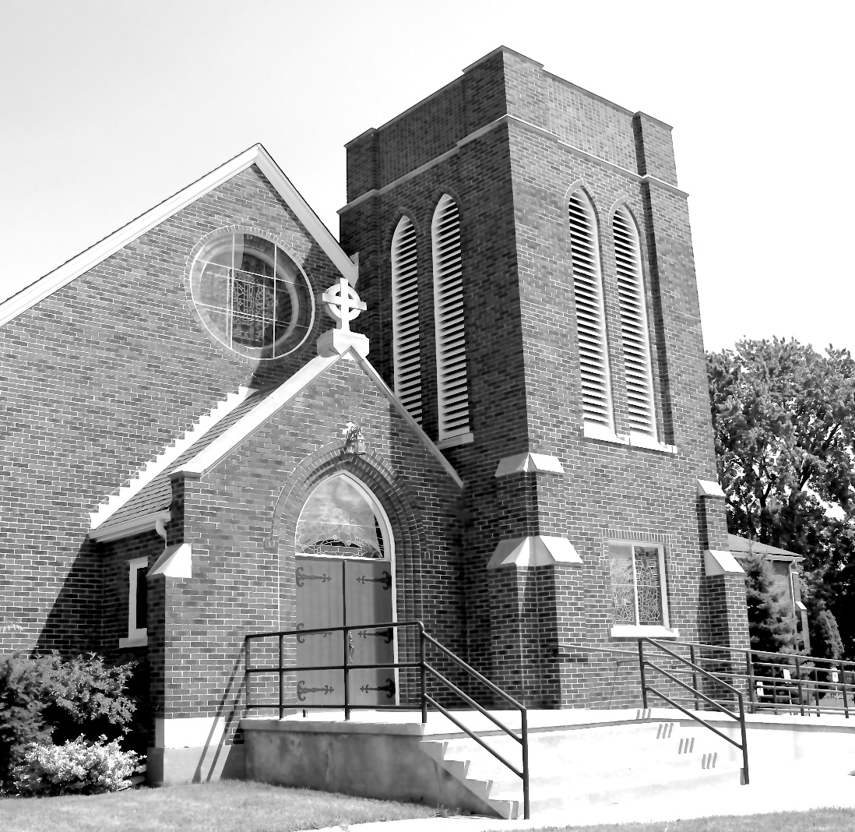

We come and worship God.
We go our way with souls nourished.
Worship Service: Sunday 9:30 a.m.
380 Russell St. North (at Maxwell St.), Sarnia, Ontario, N7T 6S6
(519) 344-9531 - http://www.canondavis.com

Canon Davis Memorial Church
Anglican Church of Canada
Sunday, February 27, 2022 – Eighth Sunday after Epiphany
Transfiguration Sunday
9:30 a.m. Morning Prayer
Officiant—Ginny Schleihauf—Organist Dorothy Miller

Opening Hymn # 393 Immortal, Invisible, God Only Wise
Greeting

The Gathering of the Community
Exhortation, General Confession and Absolution
Lord’s Prayer
Responses
Venite
The Proclamation of the Word
1st Reading: Exodus 34: 29-35
Psalm: 99
2nd Reading: II Corinthians 3: 12-4:2
Gospel: Luke: 9: 28-36
Benedictus
The Apostles’ Creed
Versicles
The Lord’s Prayer
Responses
Collect of the Day
Sermon
Sermon Hymn # 84 Lord, Enthroned in Heavenly Splendor
Prayer for the Clergy and People, and for all Conditions of Mortals
General Thanksgiving (said by all)
Prayer of Saint Chrysostom and Prayer for a Renewed Church
The Grace
Announcements
Closing Hymn # 486 Love Divine, All Loves Excelling
Dismissal
Officiant Go in peace to love and serve the Lord
People Thanks be to God.
Benediction Go Now in Peace

Morning Prayer

BA general Confession to be said of the whole Congregation with the Minister, all kneeling.

ALMIGHTY and most merciful Father, We have erred and strayed from thy ways like lost sheep, We have followed too much the devices and desires of our own hearts, We have offended against thy holy laws, We have left undone those things which we ought to have done, And we have done those things which we ought not to have done; And there is no health in us. But thou, O Lord, have mercy upon us, miserable offenders. Spare thou them, O God, which confess their faults. Restore thou them that are penitent; According to thy promises declared unto mankind in Christ Jesu our Lord. And grant, O most merciful Father, for his sake, That we may hereafter live a godly, righteous, and sober life, To the glory of thy holy Name. Amen.

The Absolution, or Remission of sins, to be pronounced by the Priest
The people shall answer here, and at the end of all other prayers:

Amen.

Here the Lord’s Prayer may be said; the people repeating it with the Minister.

OUR Father who art in heaven, Hallowed be thy Name,
Thy kingdom come, Thy will be done, on earth as it is in heaven.
Give us this day our daily bread; And forgive us our trespasses,
As we forgive them that trespass against us; And lead us not into temptation, But deliver us from evil.
For thine is the kingdom, the power, and the glory, For ever and ever. Amen.
Minister O LORD, open thou our lips;
People. And our mouth shall show forth thy praise.
Minister. O God, make speed to save us;
People. O Lord, make haste to help us.

Here, all standing up, the Minister shall say:

GLORY be to the Father, and to the Son, and to the Holy Ghost;
People. As it was in the beginning, is now, and ever shall be, world without end. Amen.
Minister. Praise ye the Lord;
People. The Lord’s Name be praised.

VENITE, EXULTEMUS DOMINO. Psalm 95.

COME, let us sing unto the LORD: / let us heartily rejoice in the strength of our salvation.

Let us come before his presence with thanksgiving, / and show ourselves glad in him with psalms.

For the LORD is a great God, / and a great King above all gods.
In his hand are all the corners of the earth: /and the strength of the hills is his also.

The sea is his, and he made it: / and his hands prepared the dry land.
O COME, let us worship, and fall down, / and kneel before the LORD our Maker.

For he is the Lord our God; / and we are the people of his pasture, and the sheep of his hand.

GLORY be to the Father, and to the Son, / and to the Holy Ghost;
As it was in the beginning, is now, and ever shall be, / world without end. Amen.

FIRST LESSON

PSALM

SECOND LESSON

GOSPEL
BENEDICTUS. St Luke 1. 68.

BLESSED be the Lord God of Israel; / for he hath visited, and redeemed his people;

And hath raised up a mighty salvation for us, /in the house of his servant David;
As he spake by the mouth of his holy Prophets, /which have been since the world began;

That we should be saved from our enemies, /and from the hands of all that hate us;

To perform the mercy promised to our forefathers, / and to remember his holy covenant;

To perform the oath which he sware to our forefather Abraham, / that he would grant us

That we being delivered out of the hands of our enemies / might serve him without fear,

In holiness and righteousness before him, / all the days of our life.

AND thou, child, shalt be called the Prophet of the Highest: / for thou shalt go before the face of the Lord to prepare his ways;

To give knowledge of salvation unto his people/ for the remission of their sins;

Through the tender mercy of our God; / whereby the day-spring from on high hath visited us;

To give light to them that sit in darkness, and in the shadow of death, / and to guide our feet into the way of peace.

GLORY be to the Father, and to the Son, / and to the Holy Ghost;

As it was in the beginning, is now, and ever shall be, / world without end. Amen.
Apostles’ Creed.
I BELIEVE in God the Father Almighty, Maker of heaven and earth:

And in Jesus Christ his only Son our Lord, Who was conceived by the Holy Ghost, Born of the Virgin Mary, Suffered under Pontius Pilate, Was crucified, dead, and buried: He descended into hell; The third day he rose again from the dead; He ascended into heaven, And sitteth on the right hand of God the Father Almighty; From thence he shall come to judge the quick and the dead.

I believe in the Holy Ghost; The holy Catholic Church; The Communion of Saints; The Forgiveness of sins; The Resurrection of the body, And the Life everlasting. Amen.

And after the Creed these prayers following, all devoutly kneeling,
the Minister first pronouncing:

The Lord be with you;
People. And with thy spirit.
Minister. Let us pray.
Lord, have mercy upon us.
Christ, have mercy upon us.
Lord, have mercy upon us.

OUR Father who art in heaven, Hallowed be thy Name,
Thy kingdom come, Thy will be done, on earth as it is in heaven.
Give us this day our daily bread; And forgive us our trespasses,
As we forgive them that trespass against us;
And lead us not into temptation, But deliver us from evil. Amen.

Then the Priest standing up shall say:

O Lord, show thy mercy upon us;
People. And grant us thy salvation.

Priest. O Lord, save the Queen;
People. And mercifully hear us when we call upon thee.

Priest. Endue thy Ministers with righteousness;
People. And make thy chosen people joyful.

Priest. O Lord, save thy people;
People. And bless thine inheritance.

Priest. Give peace in our time, O Lord;
People. And evermore mightily defend us.

Priest. O God, make clean our hearts within us;
People. And take not thy Holy Spirit from us.

THE COLLECT OF THE DAY

Almighty God, on the holy mount you revealed to chosen witnesses your well-beloved Son, wonderfully transfigured: mercifully deliver us from the darkness of this world, and change us into his likeness from glory to glory; through Jesus Christ our Lord who lives and reigns with you and the Holy Spirit, one God, now and for ever.

Sermon
Sermon Hymn
A Prayer for the Clergy and People.
Amen.

Let us pray for —,

A Prayer for all Conditions of mortals.

Amen.

A General Thanksgiving, to be said by the Minister and people together.

ALMIGHTY God, Father of all mercies, We thine unworthy servants do give thee most humble and hearty thanks For all thy goodness and loving-kindness To us and to all men; [*particularly to those who desire now to offer up their praises and thanksgivings.] We bless thee for our creation, preservation, and all the blessings of this life; But above all for thine inestimable love In the redemption of the world by our Lord Jesus Christ; For the means of grace, And for the hope of glory. And we beseech thee, give us that due sense of all thy mercies, That our hearts may be unfeignedly thankful, And that we show forth thy praise, Not only with our lips, but in our lives; By giving up ourselves to thy service, And by walking before thee in holiness and righteousness all our days; Through Jesus Christ our Lord, To whom, with thee and the Holy Ghost, be all honour and glory, world without end. Amen.

A Prayer of Saint Chrysostom.

Amen.

Prayer for a Renewed Church:

Almighty God, give us a new vision of you, of your love, of your grace and power, and then, give us a new vision of what you would have us do as your Church in this nation and at this time, and an awareness that in the strength of your Spirit, we can do it to your glory. In Jesus” name we pray. Amen.

THE Grace

Amen.

Announcements

Dismissal

Officiant Go in peace to love and serve the Lord.
People: Thanks be to God.

Benediction: Go Now in Peace

Today, in lieu of memorial flowers from the McPhail, Kimball and Fisher families, we lovingly remember our loved ones.

News and Events
- To register your attendance at Sunday Services and/or to submit announcements for the bulletin please call or contact Karen at 519-344-9531 or email canondavis@gmail.com by 11:00 a.m. Tuesday of each week.

- Please join us for Coffee Hour after service for a time of fellowship in the parish hall.

- Happy Birthday wishes to Mary Warren, Faye Farnworth, Diana Duke, and Tom Brown from all your friends at Canon Davis Memorial.

- Please let us know if you are interested in attending an Ash Wednesday and/or Good Friday Service at CDM.

Upcoming Events:

Mar 6 Bishop Todd will visit Trinity Church in Sarnia.
Mar 16 St Patrick’s Day Corned Beef and Cabbage Drive In-Take Out Dinner. Adults $20.00 Children $12.00. Please call 519 344-9531 to place your order. Thank you.
Spring Cleaning of Canon Davis Memorial. If you are available to help please call Karen at 519 344-9531.

Reminders:
Mar 23 Parish Council Meeting 10:00 a.m. in the Boardroom

