Canon Davis Memorial Church
Anglican Church of Canada
Sunday, February 20, 2022 – Seventh Sunday after Epiphany

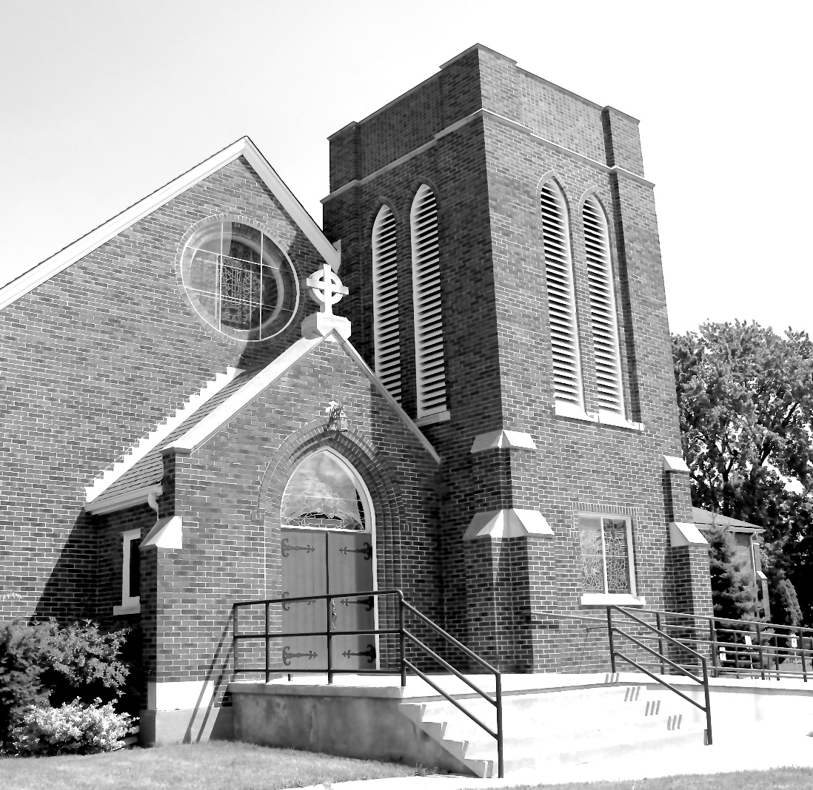

We come and worship God.
We go our way with souls nourished.
Worship Service: Sunday 9:30 a.m.
380 Russell St. North (at Maxwell St.), Sarnia, Ontario, N7T 6S6
(519) 344-9531 - http://www.canondavis.com

Dear Friends,
The Diocese previously announced that we may sing, while wearing a mask, the first two verses of the hymns during the service.
Since then, additional guidelines for the wearing of masks during the service from the Diocese reads:
- All persons in our churches must wear well-fitted face coverings that securely cover the mouth and nose. The only exemption to this requirement is for children 2 years old and younger and others who are physically unable to remove their own face covering.

- Well-fitted facemasks must be worn at all times. Presiders, preachers, readers, intercessors and soloists may not remove facemasks regardless of the distance from others or barriers that may be in place. The only time that facemasks may be removed during a service is in order to consume the Eucharist.

Canon Davis Memorial Church
Anglican Church of Canada
Sunday, February 20, 2022 – Seventh Sunday after Epiphany
9:30 a.m. Holy Eucharist
Officiant—Rev. Ray Jenkins — Organist—Dorothy Miller

THE GATHERING OF THE COMMUNITY

Opening Hymn # 399 Now Thank We All Our God

The grace of our Lord Jesus Christ, and the love of God, and the fellowship of the Holy Spirit, be with you all.
And also with you.
Almighty God, to you all hearts are open, all desires known, and from you no secrets are hidden. Cleanse the thoughts of our hearts by the inspiration of your Holy Spirit, that we may perfectly love you, and worthily magnify your holy name; through Christ our Lord. Amen.
Glory to God in the highest, and peace to his people on earth.
Lord God, heavenly king, almighty God and Father, we worship you, we give you thanks, we praise you for your glory.
Lord Jesus Christ, only Son of the Father, Lord God, Lamb of God, you take away the sin of the world: have mercy on us; you are seated at the right hand of the Father: receive our prayer.
For you alone are the Holy One, you alone are the Lord, you alone are the Most High, Jesus Christ, with the Holy Spirit, in the glory of God the Father. Amen.
Lord, have mercy. Christ, have mercy. Lord, have mercy.
COLLECT OF THE DAY: Almighty God, your Son revealed in signs and miracles the wonder of your saving love. Renew your people with your heavenly grace, and in all our weakness sustain us by your mighty power; through Jesus Christ our Lord, who is alive and reigns with you and the Holy Spirit, one God, now and for ever.
THE PROCLAMATION OF THE WORD

1st Reading: Genesis 45: 3-11, 15
Psalm: 37: 1-12, 41-42
2nd Reading: 1 Corinthians 15: 35-38, 42-50
Gospel: Luke 6: 27-38

THE HOLY GOSPEL OF OUR LORD JESUS CHRIST
ACCORDING TO LUKE
Jesus said, "But I say to you that listen, Love your enemies, do good to those who hate you, bless those who curse you, pray for those who abuse you. If anyone strikes you on the cheek, offer the other also; and from anyone who takes away your coat do not withhold even your shirt. Give to everyone who begs from you; and if anyone takes away your goods, do not ask for them again. Do to others as you would have them do to you. If you love those who love you, what credit is that to you? For even sinners love those who love them. If you do good to those who do good to you, what credit is that to you? For even sinners do the same. If you lend to those from whom you hope to receive, what credit is that to you? Even sinners lend to sinners, to receive as much again. But love your enemies, do good, and lend, expecting nothing in return. Your reward will be great, and you will be children of the Most High; for he is kind to the ungrateful and the wicked. Be merciful, just as your Father is merciful. Do not judge, and you will not be judged; do not condemn, and you will not be condemned. Forgive, and you will be forgiven; give, and it will be given to you. A good measure, pressed down, shaken together, running over, will be put into your lap; for the measure you give will be the measure you get back."
Sermon
Dear Friends,
In one of the municipalities I served as a planner was a very active lawyer. He had impeccable credentials. He had an instinct for winning cases. No client was too big; none was too small! He proudly gave me a tour of the corporate offices.

This man had a full staff. I had occasion to discuss issues with him from time to time. At one of our sessions, he glanced at my cross shaped lapel pin and asked if I was a Christian. When I nodded affirmatively, he replied by saying, I guess that means that you are not subversive to our fine city! I assured him that I was seeking the best for that municipality.

Now, if one attended one of our council meetings; or attended a city committee hearing; or read the daily local paper — and was asked if everyone supported recommended actions; one would find it difficult to reach a consensus about what actions would be best for everyone. And yet, that is what we hope for as we try to make local government work well for most folk.

Is everyone happy when government operates smoothly and efficiently? Not necessarily. And at times, those who are critical may have suggestions that lead to better municipal management! For that we are thankful.

But I have never forgotten the lawyer’s concern and relief about whether as a Christian, would that make me or other Christians constitute a threat of some kind. You may ask how that could even be in anyone’s mind.

Enter today’s Gospel Reading. Now, our Biblical texts were written because we need to hear them. If society agreed with everything written, there would be no reason for the Old and New Testaments to be recorded down through the generations. Godly wisdom would be in everyone’s mind/everyone’s heart! People would understand right and wrong. They would have God’s wisdom at the forefront of their decision making.

But in the real world — the one that God created for us; in that world, things would be different, What people would naturally do may be anything but what would be expected. Listen carefully to what we just might find ourselves doing.
• Luke 6:27 "But I say to you that listen, Love your
enemies, do good to those who hate you,

• Luke 6:28 bless those who curse you, pray for those
who abuse You

• Luke 6:29 If anyone strikes you on the cheek, offer the other
also; and from anyone who takes away your coat do not withhold even your shirt.

• Luke 6:30 Give to everyone who begs from you; and if anyone
takes away your goods, do not ask for them again.

• Luke 6:31 Do to others as you would have them do to you.

• Luke 6:32 "If you love those who love you, what credit is
that to you? For even sinners love those who love them.

• Luke 6:33 If you do good to those who do good to you, what
credit is that to you? For even sinners do the same.

• Luke 6:34 If you lend to those from whom you hope to receive,
what credit is that to you? Even sinners lend to sinners, to receive as much again.

• Luke 6:35 But love your enemies, do good, and lend,
expecting nothing in return. Your reward will be great, and you will be children of the Most High; for he is kind to the ungrateful and the wicked.

• Luke 6:36 Be merciful, just as your Father is merciful.

• Luke 6:37 "Do not judge, and you will not be judged; do not condemn, and you will not be condemned. Forgive, and you will be forgiven;

• Luke 6:38 give, and it will be given to you. A good measure, pressed down, shaken together, running over, will be put into your lap; for the measure you give will be the measure you get back."

Now, I do not think Jesus was seeking to have us memorize these to be strictly applied in our daily lives. I do think that we are being challenged to soften our hearts in ways that signify a new outlook on how we relate to one another. Essentially we are being invited into the development of a new kinder world; one that would be created by what some urban planners would call “an attitude adjustment!” one for the better, I might add. Essentially, we would be living lives of love. That is a nice place to be.

We pray now in the words of Brother Roger.

Risen Jesus, In your Gospel we discover such a clear hope.
It sustains faith even in situations where there seems to be no way out. This hope reinvents the world. Amen.

Sermon Hymn #645 Come Down, O Love Divine

The Apostles’ Creed: Let us confess the faith of our baptism, as we say,
I believe in God, the Father almighty, creator of heaven and earth. I believe in Jesus Christ, his only Son, our Lord. He was conceived by the power of the Holy Spirit and born of the Virgin Mary. He suffered under Pontius Pilate, was crucified, died, and was buried. He descended to the dead. On the third day he rose again. He ascended into heaven, and is seated at the right hand of the Father. He will come again to judge the living and the dead. I believe in the Holy Spirit, the holy catholic Church, the communion of saints, the forgiveness of sins, the resurrection of the body, and the life everlasting. Amen.

Prayers of the People

PRAYER FOR A RENEWED CHURCH: Almighty God, give us a new vision of you, of your love, of your grace and power, and then, give us a new vision of what you would have us do as your Church in this nation and at this time, and an awareness that in the strength of your Spirit, we can do it to your glory. In Jesus’ name we pray. Amen.

Confession and Absolution: Dear friends in Christ, God is steadfast in love and infinite in mercy; he welcomes sinners and invites them to his table. Let us confess our sins, confident in God’s forgiveness.

The Confession: Most merciful God,
we confess that we have sinned against you in thought, word, and deed, by what we have done, and by what we have left undone. We have not loved you with our whole heart; we have not loved our neighbours as ourselves. We are truly sorry and we humbly repent. For the sake of your Son Jesus Christ, have mercy on us and forgive us, that we may delight in your will, and walk in your ways, to the glory of your name. Amen.

Absolution: Almighty God have mercy upon you, pardon and deliver you from all your sins, confirm and strengthen you in all goodness, and keep you in eternal life; through Jesus Christ our Lord. . Amen.
The Peace

Offering Hymn # 592 Where Cross the Crowded Ways of Life

PRAYER OVER THE GIFTS: Merciful God,accept all we offer you this day. Lead us to love you with all our heart, and to love all people with your perfect love. We ask this in the name of Jesus Christ.

Eucharistic Prayer # 5
The Lord be with you.
And also with you.

Lift up your hearts.
We lift them to the Lord.

Let us give thanks to the Lord our God.
It is right to give our thanks and praise.

We give you thanks and praise, almighty God, for the gift of a world full of wonder, and for our life which comes from you. By your power you sustain the universe.
Glory to you for ever and ever.

You created us to love you with all our heart, and to love each other as ourselves, but we rebel against you by the evil that we do.

In Jesus, your son, you bring healing to our world and gather us into one great family. Therefore, with all who serve you on earth and in heaven, we praise your wonderful name, as we say,

Holy, holy, holy Lord, God of power and might, heaven and earth are full of your glory.
Hosanna in the highest.

Blessed is he who comes in the name of the Lord.
Hosanna in the highest.

We give you thanks and praise, loving Father, because in sending Jesus, your Son, to us you showed us how much you love us. He cares for the poor and the hungry. He suffers with the sick and the rejected.

Betrayed and forsaken, he did not strike back but overcame hatred with love.

On the cross he defeated the power of sin and death.
By raising him from the dead you show us the power of your love to bring new life to all your people.
Glory to you for ever and ever.

On the night before he gave up his life for us, Jesus, at supper with his friends, took bread, gave thanks to you, broke it, and gave it to them, saying, “Take this, all of you, and eat it: this is my body which is given for you.”

After supper, Jesus took the cup of wine, said the blessing, gave it to his friends, and said, “Drink this, all of you: this is the cup of my blood, the blood of the new and eternal covenant, which is shed for you and for many, so that sins may be forgiven. Do this in memory of me.”
Glory to you for ever and ever.

Gracious God, with this bread and wine we celebrate the death and resurrection of Jesus, and we offer ourselves to you in him.
Send your Holy Spirit on us and on these gifts, that we may know the presence of Jesus in the breaking of bread, and share in the life of the family of your children.
Glory to you for ever and ever.

Father, you call us to be your servants; fill us with the courage and love of Jesus, that all the world may gather in joy at the table of your kingdom.
We sing your praise, almighty Father, through Jesus, our Lord, in the power of the Holy Spirit, now and for ever.
Glory to you for ever and ever. Amen.

The Lord’s Prayer: Our Father, who art in heaven, hallowed be thy name, thy kingdom come, thy will be done, on earth as it is in heaven. Give us this day our daily bread. And forgive us our trespasses, as we forgive those who trespass against us. And lead us not into temptation, but deliver us from evil. For thine is the kingdom, the power, and the glory, for ever and ever. Amen.

Breaking of the Bread:
We break this bread to share in the body of Christ.
We, being many, are one body, for we all share in the one bread.

Communion
The gifts of God for the people of God.
Thanks be to God.

PRAYER AFTER COMMUNION: Gracious God, in the eucharist we celebrate your love for us and for all people. Grant that strengthened by these holy gifts, we may show your love in our lives, and know its fulfilment in your presence. We ask this in the name of Jesus Christ our Lord.

Almighty God, you have made us a royal priesthood in the kingdom of your Son our Saviour Jesus Christ. Make known his victory through us, we pray, that all the world may see his light. We ask this in the name of Jesus Christ the Lord.

Doxology
Glory to God, Whose power, working in us, can do infinitely more than we can ask or imagine. Glory to God from generation to generation, in the Church and in Christ Jesus, for ever and ever. Amen.

Blessing
The peace of God which passes all understanding, keep your hearts and minds in the knowledge and love of God and of his son Jesus Christ and the blessing of God Almighty the Father, the Son and the Holy Spirit be with you and those you love for ever more. Amen.
Announcements
Hymn # 614 Forgive Our Sins As We Forgive
Benediction Song Howard’s Blessing (vs 1-2)

Today in lieu of memorial flowers,we remember our Dease Family past, Bessie and Clarence, Don, Baby Bruce, Carol and Peter, Liam, John Mann and John Moser.

We pray for the repose of the souls of
Patricia (Pat) Wood
and
Muriel Smith (Coutu)

News and Events

- Please send all announcements for the bulletin to Karen by 11:00 a.m. Tuesday of each week. Call: 519-344-9531 or email: canondavis@gmail.com.
- To register your attendance at Sunday Services please contact the office at 519-344-9531. Thank you.
- Please join us for Coffee Hour after service for a time of fellowship in the parish hall.
- Wed Feb 23 Pork Drive-Through Take-Out Dinner. Cost: Adults $20.00 Children $12.00. Please call the church at 519-344-9531 to place your order and arrange your pick-up time slot. Thank you.
- Central Baptist Church Kids Konnection through their Learning and Growth Ministries – is starting a Reading Support Program to help students who have fallen behind due to Covid to “catch up”. If you know of anyone who could benefit from this program, please pass this information along.”

Upcoming Events:

- SPRING CLEANING IS COMING TO CANON DAVIS MEMORIAL
And, although the date has not been set we are looking for volunteers to help out. If you are available to help, please call Karen at 519-344-9531. Thank you.

Reminders:

